FULL STACK DEVELOPMENT – 2 LAB RECORD


SubmittedBy

Mr. SURADA GUNA SEKHAR
Regd.Number:23B91A05S3

DEPARTMENT OF COMPUTER SCIENCE AND ENGINEERING
S.R.K.R ENGINEERING COLLEGE(A)
(Affiliated to JNTU,KAKINADA)
BHIMAVARAM-534204 (2025-2026)

DEPARTMENT OF COMPUTER SCIENCE AND ENGINEERING
S. R. K. R ENGINEERING COLLEGE BHIMAVARAM



CERTIFICATE

This is to certify that the bonafide work on Full Stack Development 2 Laboratory has been submitted by Mr. SURADA GUNA SEKHAR(23B91A05S3) as part of the Full Stack Development Laboratory report. This submission is made in partial fulfillment of the requirements for the award of the Degree of Bachelor of Technology in Computer Science and Engineering during the academic year 2025-2026.

The candidate has successfully carried out this work under my supervision and guidance, adhering to the prescribed academic standards and guidelines.

Signature of Lab Incharge

INDEX

S. No | CONTENTS | Page. No | Signature
1. | Node.js | 1-5
2. | Typescript | 6-12
3. | Augmented Programs | 13-15
4. | ExpressJS – Routing, HTTP Methods, Middleware | 16-19
5. | ExpressJS – Templating, Form Data | 20-22
6. | ExpressJS – Cookies, Sessions, Authentication | 23-27
7. | ExpressJS – Database, RESTful APIs | 28-30
8. | ReactJS – Render HTML, JSX, Components – function & Class | 31-34
9. | ReactJS – Props and States, Styles, Respond to Events | 35-38
10. | ReactJS – Conditional Rendering, Rendering Lists, React Forms | 39-43
11. | ReactJS – React Router, Updating the Screen | 44-45
12. | ReactJS – Hooks, Sharing data between Components | 46-47
13. | ReactJS Applications – To-do list and Quiz | 48-53
14. | MongoDB – Installation, Configuration, CRUD operations | 54-56
15. | MongoDB – Databases, Collections and Records | 57-59
16. | Augmented Programs | 60-67

Lab Programs

Exercise-1. Node.js

A)Write a program to show the workflow of JavaScript code executable by creating a web server in Node.js.
Program:
const http = require("http");
const server = http.createServer((req, res) => {
res.writeHead(200, { "Content-Type": "text/html" });
let a = 10;
let b = 20;
let sum = a + b;
let message = `
<h2>Workflow of JavaScript Code Executed via Node.js Server</h2>
<p>JavaScript is executed on the server side using Node.js.</p>
<p>Example:</p>
<ul>
<li>a = ${a}</li>
<li>b = ${b}</li>
<li>Sum (a + b) = ${sum}</li>
</ul>
`;
res.end(message);
});
server.listen(3000, () => {
console.log("Server is running at http://localhost:3000");
});

Output:
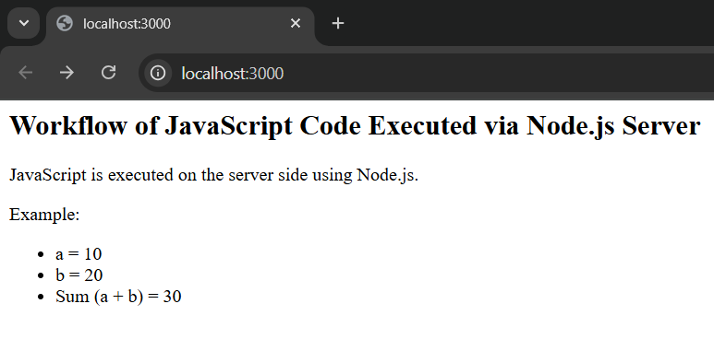

B)Write a program to Transfer data over http Protocol using http module.
Program:
// Import the http module
const http = require("http");

// Create the server
const server = http.createServer((req, res) => {
// Set response header
res.writeHead(200, { "Content-Type": "text/plain" });

// Example data to transfer
const studentData = {
id: 101,
name: "Ravi Lokesh",
course: "Full Stack Development",
marks: 95,
};

// Convert JavaScript object to JSON string
const jsonData = JSON.stringify(studentData);

// Send data as HTTP response
res.end(`Transferring Data over HTTP Protocol...\n\n${jsonData}`);
});

// Start the server
server.listen(4000, () => {
console.log("Server running at http://localhost:4000");
});

Output:
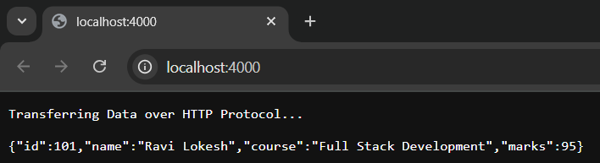

C)Create a text file src.txt and add the following content to it. (HTML, CSS, JavaScript, Typescript, MongoDB, ExpressJS, ReactJS, NodeJS)
Program:
// Import the 'fs' (File System) module
const fs = require("fs");

// Content to write into the file
const content = `HTML
CSS
JavaScript
TypeScript
MongoDB
ExpressJS
ReactJS
NodeJS`;

// Create a file named 'src.txt' and write the content
fs.writeFile("src.txt", content, (err) => {
if (err) {
console.error("Error creating file:", err);
} else {
console.log("✅ File 'src.txt' created successfully!");
}
});

Output:
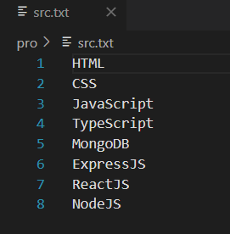

D)Write a program to parse an URL using URL module.
Program:
// Import the URL module
const url = require("url");

// Sample URL
const myURL = "https://www.example.com:8080/webpage/index.html?user=Amith&id=Q1#sectionD";

// Parse the URL
const parsedURL = url.parse(myURL, true);

// Display parts of the URL
console.log("Protocol: ", parsedURL.protocol);
console.log("Host: ", parsedURL.host);
console.log("Port: ", parsedURL.port);
console.log("Pathname: ", parsedURL.pathname);
console.log("Query Parameters: ", parsedURL.query);
console.log("Hash: ", parsedURL.hash);

Output: node p1.js
>>
Protocol: https:
Host: www.example.com:8080
Port: 8080
Pathname: /webpage/index.html
Query Parameters: [Object: null prototype] { user: 'Amith', id: 'Q1' }
Hash: #sectionD

E)Write a program to create a user-defined module and show the workflow of Modularization of application using Node.js
Program:
MathUtil.js
function add(a, b) {
return a + b;
}
function subtract(a, b) {
return a - b;
}
function multiply(a, b) {
return a * b;
}
function divide(a, b) {
if (b === 0) {
return 'Cannot divide by zero!';
}
return a / b;
}
module.exports = {
add,
subtract,
multiply,
divide
};

App.js
const math = require('./MathUtil');
console.log('Addition: 10 + 5 =', math.add(10, 5));
console.log('Subtraction: 10 - 5 =', math.subtract(10, 5));
console.log('Multiplication: 10 * 5 =', math.multiply(10, 5));
console.log('Division: 10 / 5 =', math.divide(10, 5));

Output: node p2.js
>>
Addition: 10 + 5 = 15
Subtraction: 10 - 5 = 5
Multiplication: 10 * 5 = 50
Division: 10 / 5 = 2

Exercise-2. Typescript

A) Write a program to understand simple and special types.
Program:
let age: number = 25;
let userName: string = "Ravi Lokesh";
let isStudent: boolean = true;
let scores: number[] = [85, 90, 78];
let student: [string, number] = ["Ravi Lokesh", 9];
enum Direction {
North,
South,
East,
West
}
let dir: Direction = Direction.East;
let randomValue: any = "Hello";
randomValue = 42;
randomValue = true;
let unknownValue: unknown = "possible string";
if (typeof unknownValue === "string") {
console.log("unknown value is a string");
}
function greet(): void {
console.log("Hello, Welcome!");
}
let u: undefined = undefined;
let n: null = null;
function throwError(message: string): never {
throw new Error(message);
}
console.log("Name:", userName);
console.log("Age:", age);
console.log("Is Student:", isStudent);
console.log("Scores:", scores);
console.log("Student Tuple:", student);
console.log("Direction:", Direction[dir]);
console.log(dir);
greet();

Output: tsc SimpleTypes.ts
node SimpleTypes.js
>>
unknown value is a string
Name: Ravi Lokesh
Age: 25
Is Student: true
Scores: [ 85, 90, 78 ]
Student Tuple: [ 'Ravi Lokesh', 9 ]
Direction: East
2
Hello, Welcome!

B) Write a program to understand function parameter and return types.
Program:
function add(a: number, b: number): number {
return a + b;
}
function multiply(a: number, b: number = 1): number {
return a * b;
}
function divide(a: number = 1, b: number = 1): number {
if (b === 0) {
throw new Error("Cannot divide by zero");
}
return a / b;
}
function greet1(name: string): void {
console.log(`Hello, ${name}!`);
}
function logMessage(message: string): void {
console.log(`Log: ${message}`);
}
console.log("Add (2 params):", add(10, 5));
console.log("Multiply (1 param):", multiply(7));
console.log("Multiply (2 params):", multiply(7, 3));
console.log("Divide (default params):", divide());
console.log("Divide (both params):", divide(20, 4));
greet1("Ravi Lokesh");
logMessage("This is a test message");

Output: tsc FunctionTypes.ts
node FunctionTypes.js
>>
Add (2 params): 15
Multiply (1 param): 7
Multiply (2 params): 21
Divide (default params): 1
Divide (both params): 5
Hello, Ravi Lokesh!
Log: This is a test message

C) Write a program to show the importance with Arrow function. Use optional, default and REST parameters.
Program:
const greet = (name?: string): string => {
return name ? `Hello, ${name}!` : "Hello, Guests";
};
const calculateArea = (length: number, width: number = 10): number => {
return length * width;
};
const sumAll = (...number: number[]): number => {
return number.reduce((total, num) => total + num, 0);
};
const createUser = (id: number, name: string = "Anonymous") => ({
userID: id,
username: name
});
console.log("Greeting(with name): ", greet("Lokesh"));
console.log("Greeting(without name): ", greet());
console.log("Area(with both params): ", calculateArea(5, 4));
console.log("Area(with default width): ", calculateArea(7));
console.log("sum of numbers: ", sumAll(1, 2, 3, 4, 5));
console.log("User object:", createUser(101, "John"));
console.log("User with default name: ", createUser(102));

Output: tsc ArrowFunctions.ts
node ArrowFunctions.js
>>
Greeting(with name): Hello, Lokesh!
Greeting(without name): Hello, Guests
Area(with both params): 20
Area(with default width): 70
sum of numbers: 15
User object: { userID: 101, username: 'John' }
User with default name: { userID: 102, username: 'Anonymous' }

D) Write a program to understand the working of Typescript with class, constructor, properties, methods and access specifiers.
Program:
class Student
{
// Properties with access specifiers
private id: number; // accessible only inside the class
public name: string; // accessible everywhere
protected course: string; // accessible in class and its subclasses
// Constructor to initialize properties
constructor(id: number, name: string, course: string)
{
this.id = id;
this.name = name;
this.course = course;
}
// Public method to display student details
public displayDetails(): void
{
console.log(`ID: ${this.id}`);
console.log(`Name: ${this.name}`);
console.log(`Course: ${this.course}`);
}
// Private method to show internal info
private getInternalCode(): string
{
return `STU-${this.id}-${this.course}`;
}
// Public method to access private method
public showInternalCode(): void
{
console.log("Internal Code:", this.getInternalCode());
}
}
// Subclass to demonstrate protected access
class GraduateStudent extends Student
{
private specialization: string;
constructor(id: number, name: string, course: string, specialization: string)
{
super(id, name, course);
this.specialization = specialization;
}
public displayGraduateDetails(): void
{
// Accessing protected member from base class
console.log(`${this.name} is specializing in ${this.specialization} under ${this.course} program.`);
}
}
// Create object of Student class
let student1 = new Student(9, "Lokesh", "Computer Science");
student1.displayDetails();
student1.showInternalCode();
// Create object of GraduateStudent class
let gradStudent = new GraduateStudent(21, "MohanReddy", "Degree", "B.Com");
gradStudent.displayGraduateDetails();

Output: tsc Class.ts
node Class.js
>>
ID: 9
Name: Lokesh
Course: Computer Science
Internal Code: STU-9-Computer Science
MohanReddy is specializing in B.Com under Degree program.

E) Write a program to understand the working of namespaces and modules.
Program:
mathOperations.ts
export function subtract(a: number, b: number): number
{
return a - b;
}
export function divide(a: number, b: number): number
{
if (b === 0) throw new Error("Division by zero!");
return a / b;
}
export class AdvancedCalculator
{
static cube(x: number): number
{
return x * x * x;
}
}

moduleDemo.ts
import { subtract, divide, AdvancedCalculator } from './mathOperations';
console.log("Module Subtract:", subtract(10, 3)); // 7
console.log("Module Divide:", divide(20, 4)); // 5
console.log("Module Cube:", AdvancedCalculator.cube(3)); // 27

Output: tsc moduleDemo.ts
node moduleDemo.js
>>
Module Subtract: 7
Module Divide: 5
Module Cube: 27

nameSpaceDemo.ts
namespace MathUtils {
export function add(a: number, b: number): number {
return a + b;
}
export function multiply(a: number, b: number): number {
return a * b;
}
export class Calculator {
static square(x: number): number {
return x * x;
}
}
}
// Accessing members of the namespace
console.log("Namespace Add:", MathUtils.add(3, 4)); // 7
console.log("Namespace Multiply:", MathUtils.multiply(3, 4)); // 12
console.log("Namespace Square:", MathUtils.Calculator.square(5)); // 25

Output: tsc nameSpaceDemo.ts
node nameSpaceDemo.js
>>
Namespace Add: 7
Namespace Multiply: 12
Namespace Square: 25

F) Write a program to understand generics with variables, functions and constraints.
Program:
type Box<T> = {
value: T;
};
let numberBox: Box<number> = { value: 42 };
let stringBox: Box<string> = { value: "Hello, TypeScript" };
console.log("Number Box:", numberBox.value);
console.log("String Box:", stringBox.value);
// Generic Function
function identity<T>(arg: T): T {
return arg;
}
console.log("Identity (number):", identity<number>(100));
console.log("Identity (string):", identity("Generic Function"));
// Generic Function with Multiple Types
function merge<T1, T2>(obj1: T1, obj2: T2): T1 & T2 {
return { ...obj1, ...obj2 };
}
const mergedObj = merge({ name: "Alice" }, { age: 30 });
console.log("Merged Object:", mergedObj);

Output: tsc genType.ts
node genType.js
>>
Number Box: 42
String Box: Hello, TypeScript
Identity (number): 100
Identity (string): Generic Function
Merged Object: { name: 'Alice', age: 30 }

Exercise-3. Augmented Programs

A) Write a CSS program, to apply 2D and 3D transformations in a web page.
Program:
<!DOCTYPE html>
<html lang="en">
<head>
<meta charset="UTF-8">
<title>2D & 3D Transformations</title>
<style>
body {
font-family: Arial, sans-serif;
text-align: center;
margin-top: 50px;
background: #f0f0f0;
}

.box {
width: 150px;
height: 150px;
margin: 20px auto;
line-height: 150px;
color: white;
font-weight: bold;
transition: transform 0.5s;
}

.box2d {
background: #3498db;
}

.box2d:hover {
transform: rotate(45deg) scale(1.2);
}

.box3d {
background: #e74c3c;
transform-style: preserve-3d;
perspective: 600px;
}

.box3d:hover {
transform: rotateY(180deg);
}
</style>
</head>
<body>
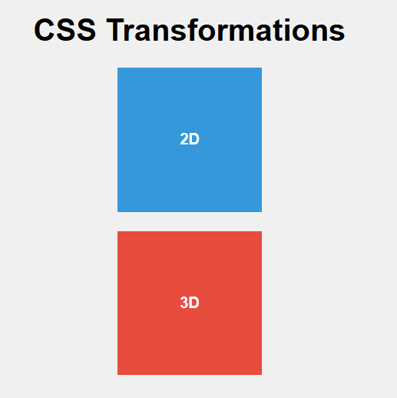
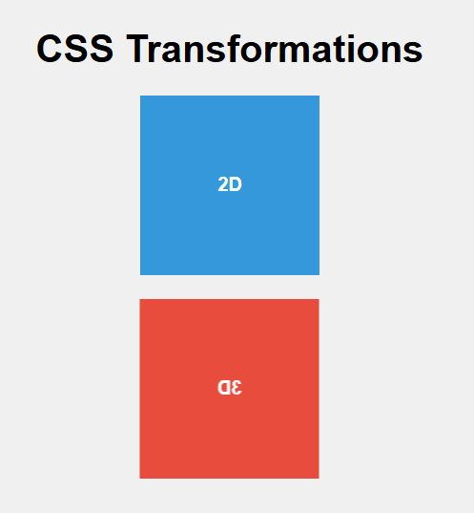
Output:
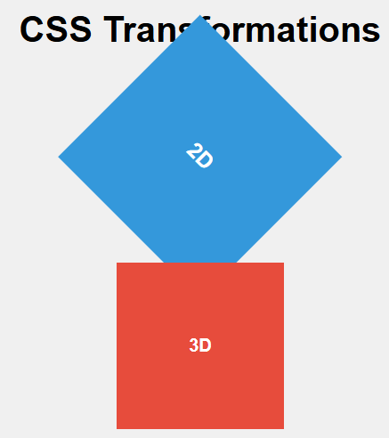

C) Design a to-do list application using JavaScript.
Program:
<!DOCTYPE html>
<html lang="en">
<head>
<meta charset="UTF-8">
<title>To-Do List App</title>

</head>
<body>

<div id="todo-container">
<h2>My To-Do List</h2>
<input type="text" id="taskInput" placeholder="Enter a task">
<button onclick="addTask()">Add</button>
<ul id="taskList"></ul>
</div>

<script>
function addTask() {
const taskInput = document.getElementById("taskInput");
const taskList = document.getElementById("taskList");

if (taskInput.value.trim() !== "") {
const li = document.createElement("li");
li.textContent = taskInput.value;

const deleteBtn = document.createElement("button");
deleteBtn.textContent = "Delete";
deleteBtn.className = "delete-btn";
deleteBtn.onclick = function () {
taskList.removeChild(li);
};

li.appendChild(deleteBtn);
taskList.appendChild(li);
taskInput.value = "";
}
}
</script>

</body>
</html>
Output:
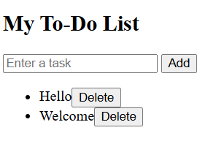

Exercise-4. ExpressJS Routing, HTTP Methods, Middleware

A) Write a program to define a route, Handling Routes, Route Parameters, Query Parameters and URL building.
Program:
// Import express
const express = require("express");
const app = express();

// 1. Define a basic route
app.get("/", (req, res) => {
res.send("Welcome to the Home Page");
});

// 2. Handling multiple routes
app.get("/about", (req, res) => {
res.send("This is the About Page");
});

app.get("/contact", (req, res) => {
res.send("This is the Contact Page");
});

// 3. Route Parameters (Example: /user/101)
app.get("/user/:id", (req, res) => {
const userId = req.params.id; // extract route parameter
res.send(`You requested details of User ID: ${userId}`);
});

// 4. Query Parameters (Example: /search?name=John&age=25)
app.get("/search", (req, res) => {
const name = req.query.name;
const age = req.query.age;
res.send(`Search Results → Name: ${name}, Age: ${age}`);
});

// 5. URL Building (Dynamic Links)
app.get("/products", (req, res) => {
const links = `
<h2>Product List</h2>
<ul>
<li><a href="/product/101">Product 101</a></li>
<li><a href="/product/102">Product 102</a></li>
<li><a href="/product/103">Product 103</a></li>
</ul>
`;
res.send(links);
});

// Route with parameters for product details
app.get("/product/:pid", (req, res) => {
res.send(`You are viewing details of Product ID: ${req.params.pid}`);
});

// Start server
app.listen(3000, () => {
console.log("Server running at http://localhost:3000");
});

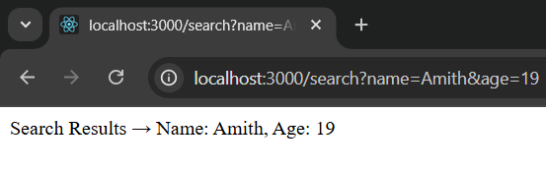
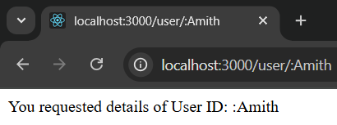
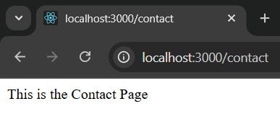
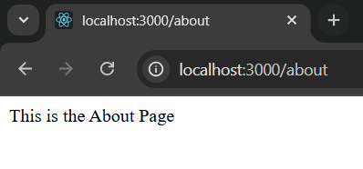
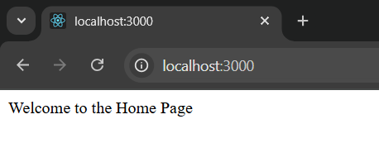
Output:
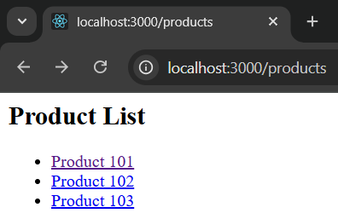
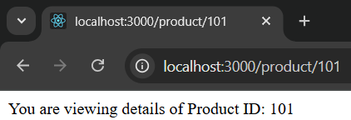
B) Write a program to accept data, retrieve data and delete a specified resource using http methods.
Program:
const express = require('express');
const app = express();
app.use(express.json()); // to read JSON data

// Temporary data store
let data = [];

// POST → Add data
app.post('/data', (req, res) => {
data.push(req.body); // add received data to array
res.send('Data added successfully');
});

// GET → Retrieve all data
app.get('/data', (req, res) => {
res.json(data);
});

// DELETE → Delete data by index
app.delete('/data/:index', (req, res) => {
const index = req.params.index;
if (data[index]) {
data.splice(index, 1); // remove item
res.send('Data deleted successfully');
} else {
res.send('No data found at this index');
}
});

// Start server
app.listen(3000, () => {
console.log('Server running at http://localhost:3000');
});

Output: >node exp2.js
Server running at http://localhost:3000

>curl http://localhost:3000/data
[]
>curl -X POST http://localhost:3000/data -H "Content-Type: application/json" -d "{\"name\":\"Ravi_Lokesh\"}"
Data added successfully
>curl http://localhost:3000/data
[{"name":"Ravi_Lokesh"}]
>curl -X DELETE http://localhost:3000/data/0
Data deleted successfully

C) Write a program to show the working of middleware.
Program:
const express = require("express");
const app = express();

// Middleware function (runs before every request)
app.use((req, res, next) => {
console.log("Middleware: Request received at " + new Date().toLocaleTimeString());
next(); // move to the next step (the route)
});

// Route 1
app.get("/", (req, res) => {
res.send("Welcome to Home Page");
});
// Route 2
app.get("/about", (req, res) => {
res.send("This is the About Page");
});
// Start server
app.listen(3000, () => {
console.log("Server running at http://localhost:3000");
});
Output:
>node exp3.js
Server running at http://localhost:3000
Middleware: Request received at 11:27:26 am

Exercise-5. ExpressJS – Templating, Form Data

A) Write a program using templating engine.
Program:
exp4.js
npm install express ejs
const express = require("express");
const app = express();
// Set EJS as the template engine
app.set("view engine", "ejs");
// Route
app.get("/", (req, res) => {
const student = { name: "Alice", age: 21, course: "Computer Science" };
res.render("index", { student: student });
});
app.listen(3000, () => {
console.log("Server running on http://localhost:3000");
});
create a folder views and create index.ejs file in it
index.ejs
<!DOCTYPE html>
<html>
<head>
<title>Student Info</title>
</head>
<body>
<h1>Welcome <%= student.name %></h1>
<p>Age: <%= student.age %></p>
<p>Course: <%= student.course %></p>
</body>
</html>
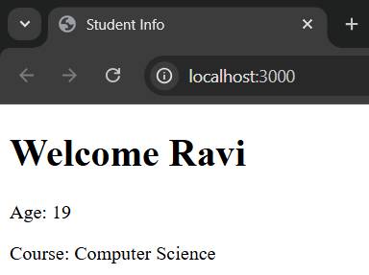
Output:

B) Write a program to work with form data.
Program:
npm install express body-parser ejs
exp5.js
const express = require("express");
const bodyParser = require("body-parser");
const app = express();
// Middleware to parse form data
//This line enables Express to read form data (like inputs from HTML forms).
app.use(bodyParser.urlencoded({ extended: true }));
// Set EJS as the template engine
app.set("view engine", "ejs");
// Route to show form
app.get("/", (req, res) => {
res.render("form"); // renders views/form.ejs
});
// Route to handle form submission
app.post("/submit", (req, res) => {
const name = req.body.name; // get "name" from form
const email = req.body.email; // get "email" from form
res.render("result", { name: name, email: email });
});
app.listen(3000, () => {
console.log("Server running on http://localhost:3000");
});

form.ejs
<!DOCTYPE html>
<html>
<head>
<title>Form Example</title>
</head>
<body>
<h1>Student Registration</h1>
<form action="/submit" method="POST">
<label>Name:</label>
<input type="text" name="name" required><br><br>
<label>Email:</label>
<input type="email" name="email" required><br><br>
<button type="submit">Submit</button>
</form>
</body>
</html>
result.ejs
<!DOCTYPE html>
<html>
<head>
<title>Form Result</title>
</head>
<body>
<h1>Form Submitted Successfully!</h1>
<p><strong>Name:</strong> <%= name %></p>
<p><strong>Email:</strong> <%= email %></p>
</body>
</html>

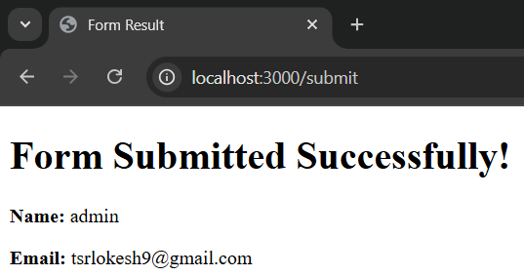
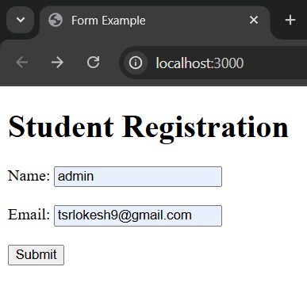
Output:

Exercise-6. ExpressJS – Cookies, Sessions, Authentication

A)Write a program for session management using cookies and sessions.
Program:
cookies.js
const express = require("express");
const cookieParser = require("cookie-parser");
const app = express();
app.use(cookieParser());
app.use(express.urlencoded({ extended: true }));
// Set a cookie when user logs in
app.post("/login", (req, res) => {
const username = req.body.username || "Guest";
res.cookie("userName", username, { maxAge: 60000 }); // 1 min cookie
res.send(`Cookie set! Welcome, ${username}`);
});
// Read the cookie when the user revisits
app.get("/", (req, res) => {
const user = req.cookies.userName;
if (user) {
res.send(`Welcome back, ${user}!`);
} else {
res.send("Hello! Please <form action='/login' method='post'><input name='username'><button>Login</button></form>");
}
});
// Clear the cookie
app.get("/logout", (req, res) => {
res.clearCookie("userName");
res.send("Logged out. Cookie cleared.");
});
app.listen(3000, () => console.log("Server running on http://localhost:3000"));

Output:
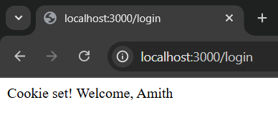
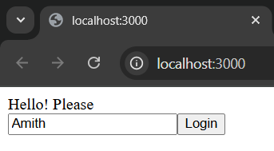

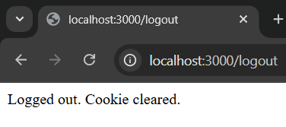
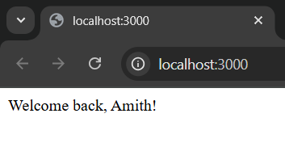

sessions.js
const express = require("express");
const session = require("express-session");

const app = express();
app.use(express.urlencoded({ extended: true }));

//Session middleware
app.use(
session({
secret: "mySecretKey", // used to sign session ID
resave: false,
saveUninitialized: true,
cookie: { maxAge: 60000 }, // 1 min session
})
);

// Login route (starts a session)
app.post("/login", (req, res) => {
const username = req.body.username || "Guest";
req.session.userName = username;
res.send(`Session started for ${username}`);
});

// Home route (check session)
app.get("/", (req, res) => {
if (req.session.userName) {
res.send(`Welcome back, ${req.session.userName}! <a href="/logout">Logout</a>`);
} else {
res.send(`
<form method="post" action="/login">
<input name="username" placeholder="Enter name">
<button>Login</button>
</form>
`);
}
});

// Logout route (destroy session)
app.get("/logout", (req, res) => {
req.session.destroy(() => {
res.send("You are logged out. Session ended.");
});
});

app.listen(3000, () => console.log("Server running on http://localhost:3000"));

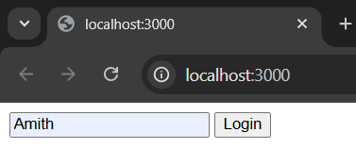
Output:
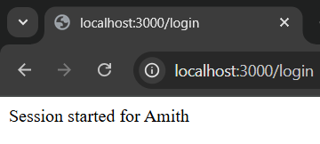

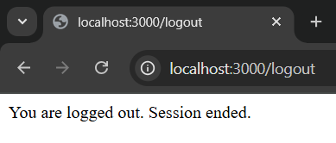
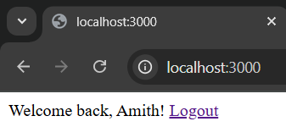
B) Write a program for user authentication.
Program:
auth.js
const express = require("express");
const session = require("express-session");
const app = express();

app.use(express.urlencoded({ extended: true })); // to read form data

// use session to store login info
app.use(
session({
secret: "mySecret",
resave: false,
saveUninitialized: true,
})
);

// Simple login form
app.get("/", (req, res) => {
res.send(`
<h2>Login Page</h2>
<form action="/login" method="POST">
Username: <input type="text" name="username"/><br>
Password: <input type="password" name="password"/><br>
<button type="submit">Login</button>
</form>
`);
});

// Check login details
app.post("/login", (req, res) => {
const { username, password } = req.body;

// Simple check (in real apps, check database)
if (username === "admin" && password === "1234") {
req.session.user = username; // store user in session
res.send(`<h3>Welcome ${username}!</h3><a href="/protected">Go to Protected Page</a>`);
} else {
res.send("<h3>Invalid username or password</h3><a href='/'>Try again</a>");
}
});

// Protected route (only for logged-in users)
app.get("/protected", (req, res) => {
if (req.session.user) {
res.send(`<h2>This is a protected page. Hello, ${req.session.user}!</h2>`);
} else {
res.send("<h3>You are not logged in!</h3><a href='/'>Login here</a>");
}
});

// Logout
app.get("/logout", (req, res) => {
req.session.destroy(() => {
res.send("<h3>You have been logged out.</h3><a href='/'>Login again</a>");
});
});

app.listen(3000, () => {
console.log("Server running on http://localhost:3000");
});

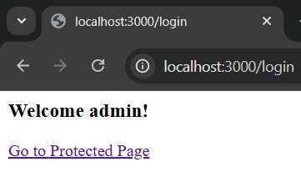
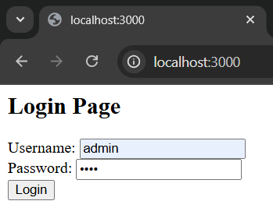
Output:

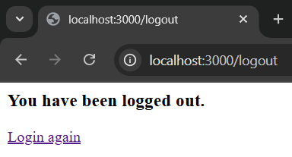
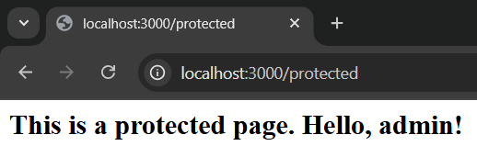

Exercise-7. ExpressJS – Database, RESTful APIs

A)Write a program to connect MongoDB database using Mongoose and perform CRUD operations
Program:
// Import mongoose
const mongoose = require("mongoose");

// Connect to local MongoDB "ravi" database
mongoose.connect("mongodb://localhost:27017/ravi", {
useNewUrlParser: true,
useUnifiedTopology: true
})
.then(() => console.log("Connected to MongoDB"))
.catch(err => console.error("Connection error:", err));

// Define schema (only name and age)
const studentSchema = new mongoose.Schema({
name: String,
age: Number,
branch: String
});

// Use existing collection "student"
const Student = mongoose.model("Student", studentSchema, "student");

// ----------------------------
// CRUD Operations
// ----------------------------

// CREATE: Insert a student
async function createStudent() {
const student = new Student({ name: "Anil", age: 20 , branch:"CSE"});
await student.save();
console.log("Student inserted");
}

// READ: Find all students
async function readStudents() {
const students = await Student.find();
console.log("All Students:", students);
}

// UPDATE: Update student's age
async function updateStudent() {
await Student.updateOne({ name: "Anil" }, { $set: { age: 21 } });
console.log("Student updated");
}

// DELETE: Delete a student
async function deleteStudent() {
await Student.deleteOne({ name: "Anil" });
console.log("Student deleted");
}

// Run operations
async function run() {
await createStudent();
await readStudents();
await updateStudent();
await readStudents();
await deleteStudent();
await readStudents();
mongoose.connection.close();
}

run();

Output: node p1.js
>>
Connected to MongoDB
Student inserted
All Students: [
{
_id: new ObjectId('68e899f74675904b6bb1f33e'),
name: 'srinu',
age: 25,
branch: 'CSE'
},
{
_id: new ObjectId('68e8d46795f505b366ab605a'),
name: 'Anil',
age: 20,
branch: 'CSE',
__v: 0
}
]
Student updated
All Students: [
{
_id: new ObjectId('68e899f74675904b6bb1f33e'),
name: 'srinu',
age: 25,
branch: 'CSE'
},
{
_id: new ObjectId('68e8d46795f505b366ab605a'),
name: 'Anil',
age: 21,
branch: 'CSE',
__v: 0
}
]
Student deleted
All Students: [
{
_id: new ObjectId('68e899f74675904b6bb1f33e'),
name: 'srinu',
age: 25,
branch: 'CSE'
}
]

Exercise-8. ExpressJS Routing, HTTP Methods, Middleware

A) Write a program to render HTML to a web page.
Program:
App.js
import React from "react";
function App() {
return (
<div>
<h1>Hello Students</h1>
<p>Welcome to React! This is your first rendered page.</p>
</div>
);
}
export default App;

index.js
import React from "react";
import ReactDOM from "react-dom/client";
import App from "./App";
// Create a root linked to the "root" div in index.html
const root = ReactDOM.createRoot(document.getElementById("root"));
// Render the App component inside that root
root.render(<App />);

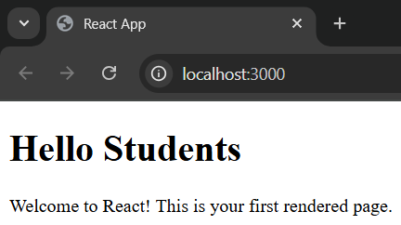
Output:

B) Write a program for writing markup with JSX.
Program:

App.js
import React from "react";
function App() {
// JSX markup
return (
<div>
<h1>Welcome to JSX!</h1>
<p>This looks like HTML, but it's actually JSX.</p>
<ul>
<li>Easy to write</li>
<li>Looks like HTML</li>
<li>Powers React Components</li>
</ul>
</div>
);
}
export default App;

index.js
import React from "react";
import ReactDOM from "react-dom/client";
import App from "./App";
const root = ReactDOM.createRoot(document.getElementById("root"));
root.render(<App />);

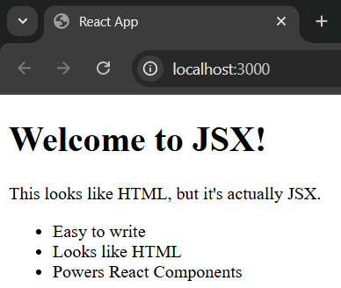
Output:

C) Write a program for creating and nesting components (function and class).
Program:

Student.js
import React from "react";
function Student() {
return (
<div>
<h2>Student Component</h2>
<p>This is a Function Component.</p>
</div>
);
}
export default Student;

Teacher.js
import React, { Component } from "react";
class Teacher extends Component {
render() {
return (
<div>
<h2>Teacher Component</h2>
<p>This is a Class Component.</p>
</div>
);
}
}
export default Teacher;

App.js
import React from "react";
import Student from "./Student";
import Teacher from "./Teacher";
function App() {
return (
<div>
<h1>Welcome to Component Nesting</h1>
<p>Below we are nesting components:</p>
{/* Nesting Function Component */}
<Student />
{/* Nesting Class Component */}
<Teacher />
</div>
);
}
export default App;

index.js
import React from "react";
import ReactDOM from "react-dom/client";
import App from "./App";
const root = ReactDOM.createRoot(document.getElementById("root"));
root.render(<App />);

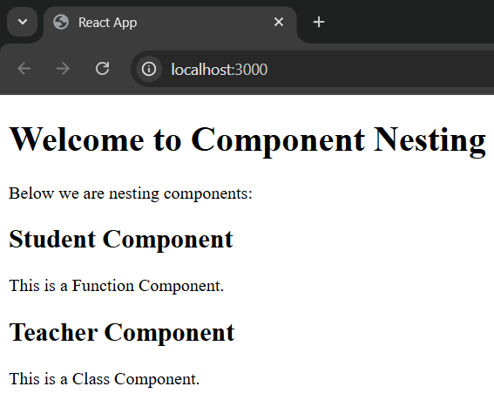
Output:

Exercise-9. ReactJS – Props and States, Styles, Respond to Events

A) Write a program to work with props and states.
Program:
App.js
import React, { useState } from "react";
// Child Component
function User(props) {
const [age] = useState(25); // simple state with fixed value
return (
<div>
<h2>Name: {props.name}</h2> {/* Using props */}
<p>Age: {age}</p> {/* Using state */}
</div>
);
}
// Parent Component
function App() {
return (
<div>
<h1>Props and State Example</h1>
<User name="Srinivas" />
<User name="Mokshith" />
<User name="Ravi" />
</div>
);
}
export default App;

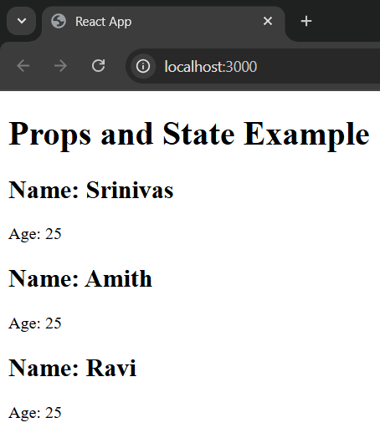
Output:

B) Write a program to add styles (CSS & Sass Styling) and display data.
Program:

App.js

import React, { useState } from "react";
import "./App.css"; // importing CSS
//import "./App.scss"; // importing SCSS

function App() {
// useState hook to manage counter value
const [count, setCount] = useState(0); //It initializes the counter to zero

return (
<div className="container">
<h1>Counter App</h1>
<h2>{count}</h2>
<button className="button" onClick={() => setCount(count + 1)}>Increment</button>
<button className="button" onClick={() => setCount(count - 1)}>Decrement</button>
<button className="button" onClick={() => setCount(0)}>Reset</button>
</div>
);
}

export default App;

App.css
.container {
text-align: center;
margin-top: 50px;
}

.button {
background-color: blue;
color: white;
padding: 10px 15px;
border: none;
margin: 5px;
border-radius: 5px;
cursor: pointer;
}

App.scss
$primary-color: purple; // variable

.container {
text-align: center;
margin-top: 50px;

h1 {
color: $primary-color; // using variable
}

.button {
background-color: $primary-color;
color: white;
padding: 10px 15px;
border: none;
margin: 5px;
border-radius: 5px;
cursor: pointer;

&:hover { // nesting with hover effect
background-color: darken($primary-color, 10%);
}
}
}

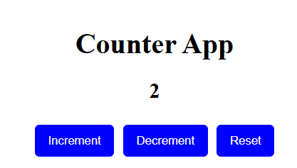
Output:
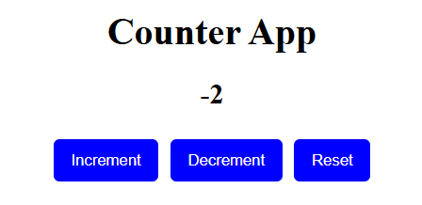
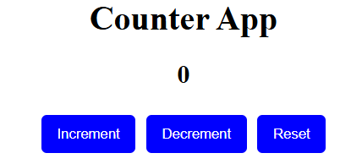

C) Write a program for responding to events.
Program:
App.js

import React, { useState } from "react";

function App() {
const [text, setText] = useState("");

function handleChange(event) {
setText(event.target.value);
}

return (
<div>
<center>
<h2>Type Something:</h2>
<input type="text" onChange={handleChange} />
<p>You typed: {text}</p>
</center>
</div>
);
}

export default App;

Output:
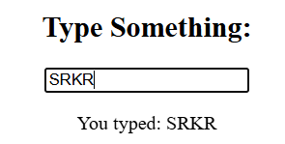

Exercise-10. ReactJS – Conditional Rendering, Rendering Lists, React Forms

A) Write a program for conditional rendering.
Program:
App.js
import React, { useState } from "react";
function App() {
const [isLoggedIn, setIsLoggedIn] = useState(false);
function handleLogin() {
setIsLoggedIn(true);
}
function handleLogout() {
setIsLoggedIn(false);
}
return (
<div style={{ textAlign: "center", marginTop: "50px" }}>
{isLoggedIn ? (
<div>
<h1>Welcome Back, User!</h1>
<button onClick={handleLogout}>Logout</button>
</div>
) : (
<div>
<h1>Please Login</h1>
<button onClick={handleLogin}>Login</button>
</div>
)}
</div>
);
}
export default App;

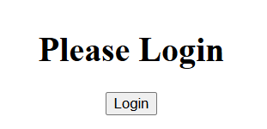
Output:
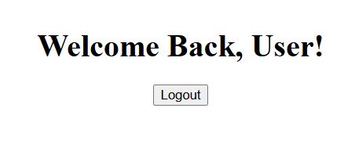

B) Write a program for rendering lists.
Program:
App.js

import React from "react";
function App() {
const fruits = ["Apple", "Banana", "Mango", "Orange"];
return (
<div style={{ textAlign: "center", marginTop: "30px" }}>
<h2>Fruit List</h2>
<ul>
{fruits.map((fruit, index) => (
<li key={index}>{fruit}</li>
))}
</ul>
</div>
);
}
export default App;

Output:

Fruit List
- Apple
- Banana
- Mango
- Orange

C) Write a program for working with different form fields using react forms.
Program:
App.js

import React, { useState } from "react";
function App() {
// State to store form data
const [formData, setFormData] = useState({
name: "",
email: "",
password: "",
gender: "",
country: "",
agree: false,
});
// Handle input changes
function handleChange(e) {
const { name, value, type, checked } = e.target;
setFormData({
...formData,
[name]: type === "checkbox" ? checked : value,
});
}
// Handle form submission
function handleSubmit(e) {
e.preventDefault();
alert("Form Submitted:\n" + JSON.stringify(formData, null, 2));
}
return (
<div style={{ textAlign: "center", marginTop: "30px" }}>
<h2>React Form Example</h2>
<form onSubmit={handleSubmit} style={{ maxWidth: "400px", margin: "0 auto", textAlign: "left" }}>
{/* Text Field */}
<label>
Name:
<input
type="text"
name="name"
value={formData.name}
onChange={handleChange}
/>
</label>
<br /><br />
{/* Email Field */}
<label>
Email:
<input
type="email"
name="email"
value={formData.email}
onChange={handleChange}
/>
</label>
<br /><br />
{/* Password Field */}
<label>
Password:
<input
type="password"
name="password"
value={formData.password}
onChange={handleChange}
/>
</label>
<br /><br />
{/* Radio Buttons */}
<label>Gender:</label><br />
<label>
<input
type="radio"
name="gender"
value="Male"
checked={formData.gender === "Male"}
onChange={handleChange}
/>
Male
</label>
<label>
<input
type="radio"
name="gender"
value="Female"
checked={formData.gender === "Female"}
onChange={handleChange}
/>
Female
</label>
<br /><br />
{/* Dropdown */}
<label>
Country:
<select name="country" value={formData.country} onChange={handleChange}>
<option value="">-- Select Country --</option>
<option value="India">India</option>
<option value="USA">USA</option>
<option value="UK">UK</option>
</select>
</label>
<br /><br />
{/* Checkbox */}
<label>
<input
type="checkbox"
name="agree"
checked={formData.agree}
onChange={handleChange}
/>
I agree to the terms and conditions
</label>
<br /><br />
{/* Submit Button */}
<button type="submit">Submit</button>
</form>
</div>
);
}
export default App;

Output:
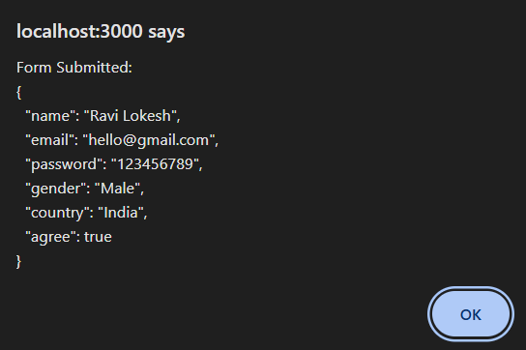
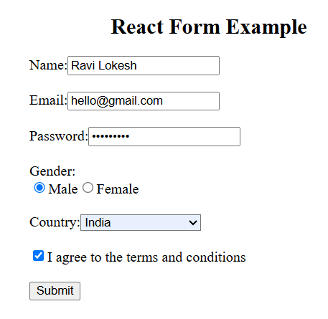

Exercise-11. ReactJS – React Router, Updating the Screen

A) Write a program for routing to different pages using react router.
Program:

Install React Router: npm install react-router-dom
App.js
import React from "react";
import { BrowserRouter as Router, Routes, Route, Link } from "react-router-dom";
function Home() {
return <h2>Home Page</h2>;
}
function About() {
return <h2>About Page</h2>;
}
function Contact() {
return <h2>Contact Page</h2>;
}
function App() {
return (
<Router>
<nav>
<Link to="/">Home</Link> |{" "}
<Link to="/about">About</Link> |{" "}
<Link to="/contact">Contact</Link>
</nav>
<Routes>
<Route path="/" element={<Home />} />
<Route path="/about" element={<About />} />
<Route path="/contact" element={<Contact />} />
</Routes>
</Router>
);
}
export default App;
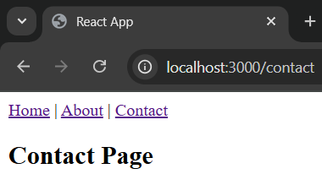
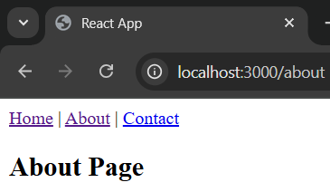
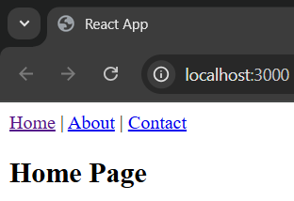
Output:

B) Write a program for updating the screen.
Program:
App.js
import React, { useState } from "react";
function App() {
// Declare a state variable "count"
const [count, setCount] = useState(0);
// Function to update count
function handleClick() {
setCount(count + 1);
}
return (
<div style={{ textAlign: "center", marginTop: "50px" }}>
<h1>Screen Update Example</h1>
<p>You clicked {count} times</p>
<button onClick={handleClick}>Click Me</button>
</div>
);
}
export default App;

Output:
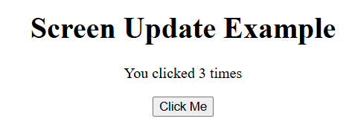

Exercise-12. ReactJS – Hooks, Sharing data between Components

A)Write a program to understand the importance of using hooks.
Program:
App.js
import React, { useState, useEffect } from "react";
function CounterWithHooks() {
// useState Hook for managing count state
const [count, setCount] = useState(0);
// useEffect Hook for side effects (like lifecycle methods in classes)
useEffect(() => {
document.title = `You clicked ${count} times`;
}, [count]); // runs whenever count changes
return (
<div style={{ textAlign: "center", marginTop: "30px" }}>
<h2>Counter using Hooks</h2>
<p>You clicked {count} times</p>
<button onClick={() => setCount(count + 1)}>Click Me</button>
</div>
);
}
export default CounterWithHooks;

Output:
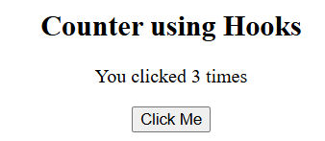

B) Write a program for sharing data between components.
Program:
App.js
import React, { useState } from "react";
// Component that displays user name
function DisplayUser({ user }) {
return <h2>Current User: {user}</h2>;
}
// Component that updates user name
function UpdateUser({ setUser }) {
return (
<button onClick={() => setUser("Lokesh")}>
Change User
</button>
);
}
// Main App Component
function App() {
const [user, setUser] = useState("Ravi"); // shared data state
return (
<div style={{ textAlign: "center", marginTop: "40px" }}>
<h1>Sharing Data Between Components (Props)</h1>
{/* Passing props to child components */}
<DisplayUser user={user} />
<UpdateUser setUser={setUser} />
</div>
);
}
export default App;

Output:
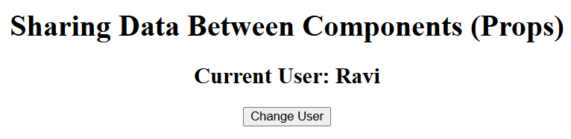

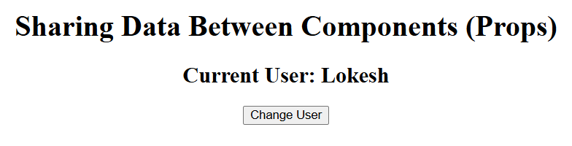

Exercise-13. ReactJS Applications – To-do list and Quiz

Design a to-do list application.
Program:
App.js:
import React, { useState } from 'react';
import './App.css'; // We will create this CSS file next

function App() {
// --- STATE ---
// `todos`: an array of todo objects [{ id, text, isCompleted }]
// `setTodos`: the function to update the todos state
const [todos, setTodos] = useState([
{ id: 1, text: 'Learn about React Hooks', isCompleted: true },
{ id: 2, text: 'Build a to-do list app', isCompleted: false },
{ id: 3, text: 'Deploy the app to Netlify', isCompleted: false },
]);

// `inputValue`: a string for the controlled input field
// `setInputValue`: the function to update the input's value
const [inputValue, setInputValue] = useState('');

// --- HANDLER FUNCTIONS ---

/**
* Handles form submission to add a new todo.
*/
const handleAddTodo = (e) => {
// Prevent the default browser refresh on form submission
e.preventDefault();

// Don't add a todo if the input is empty
if (inputValue.trim() === '') return;

// Create a new todo object
const newTodo = {
id: Date.now(), // Use a timestamp for a unique ID
text: inputValue,
isCompleted: false,
};

// Update the todos state by adding the new todo to the existing array
setTodos([...todos, newTodo]);

// Clear the input field after adding
setInputValue('');
};

/**
* Toggles the completion status of a todo item.
* @param {number} id - The ID of the todo to toggle.
*/
const handleToggleComplete = (id) => {
const updatedTodos = todos.map((todo) =>
todo.id === id ? { ...todo, isCompleted: !todo.isCompleted } : todo
);
setTodos(updatedTodos);
};

/**
* Deletes a todo item from the list.
* @param {number} id - The ID of the todo to delete.
*/
const handleDeleteTodo = (id) => {
// Filter out the todo with the matching ID
const remainingTodos = todos.filter((todo) => todo.id !== id);
setTodos(remainingTodos);
};

// --- JSX (RENDER) ---
return (
<div className="todo-app">
<h1>To-Do List</h1>

{/* Form for adding new todos */}
<form onSubmit={handleAddTodo} className="todo-form">
<input
type="text"
className="todo-input"
value={inputValue}
onChange={(e) => setInputValue(e.target.value)}
placeholder="Add a new task..."
/>
<button type="submit" className="todo-button">Add</button>
</form>

{/* List of all todos */}
<ul className="todo-list">
{todos.map((todo) => (
<li
key={todo.id}
className={`todo-item ${todo.isCompleted ? 'completed' : ''}`}
>
<span onClick={() => handleToggleComplete(todo.id)}>
{todo.text}
</span>
<button
onClick={() => handleDeleteTodo(todo.id)}
className="delete-button"
>
&times;
</button>
</li>
))}
</ul>
</div>
);
}

export default App;

App.css
/* General App Styling */
body {
font-family: -apple-system, BlinkMacSystemFont, 'Segoe UI', Roboto, 'Helvetica Neue', Arial, sans-serif;
background: #f0f2f5;
display: flex;
justify-content: center;
align-items: center;
min-height: 100vh;
margin: 0;
}

.todo-app {
background: #ffffff;
width: 100%;
max-width: 500px;
padding: 30px;
border-radius: 12px;
box-shadow: 0 10px 30px rgba(0, 0, 0, 0.1);
}

h1 {
color: #333;
text-align: center;
margin-bottom: 25px;
}

/* Form Styling */
.todo-form {
display: flex;
margin-bottom: 20px;
}

.todo-input {
flex-grow: 1;
padding: 12px 15px;
font-size: 16px;
border: 2px solid #ddd;
border-radius: 8px;
margin-right: 10px;
transition: border-color 0.3s;
}

.todo-input:focus {
outline: none;
border-color: #6c63ff;
}

.todo-button {
padding: 12px 20px;
font-size: 16px;
font-weight: bold;
color: #fff;
background-color: #6c63ff;
border: none;
border-radius: 8px;
cursor: pointer;
transition: background-color 0.3s;
}

.todo-button:hover {
background-color: #574bda;
}

/* List Styling */
.todo-list {
list-style-type: none;
padding: 0;
margin: 0;
}

.todo-item {
display: flex;
align-items: center;
justify-content: space-between;
padding: 15px;
border-bottom: 1px solid #eee;
transition: background-color 0.2s;
}

.todo-item:last-child {
border-bottom: none;
}

.todo-item span {
cursor: pointer;
flex-grow: 1;
color: #444;
}

/* Styling for completed items */
.todo-item.completed span {
text-decoration: line-through;
color: #aaa;
}

.delete-button {
background: none;
border: none;
color: #ff4d4d;
font-size: 24px;
font-weight: bold;
cursor: pointer;
padding: 0 5px;
opacity: 0.5;
transition: opacity 0.3s;
}

.todo-item:hover .delete-button {
opacity: 1;
}

Output:
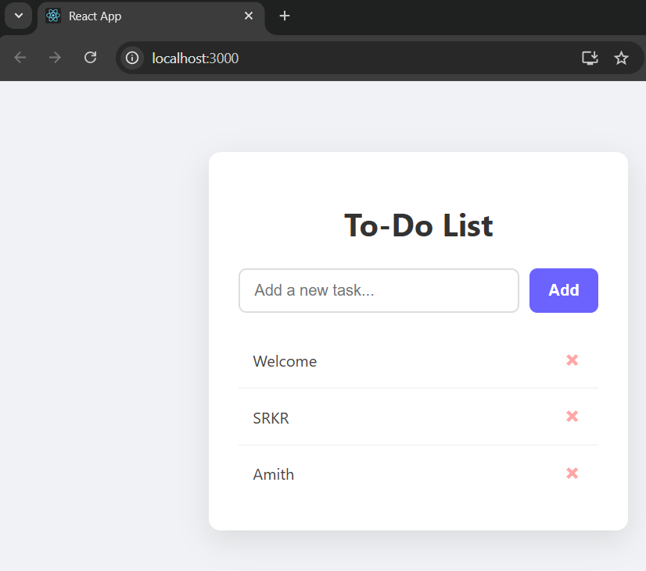

Exercise-14. MongoDB – Installation, Configuration, CRUD operations

A)Install MongoDB and configure ATLAS
Process:
Step 1: Download MongoDB
- Open your browser and go to the official MongoDB download page:
https://www.mongodb.com/try/download/community
- Under “Version”, select the latest stable release.
- Under “OS”, select Windows.
- Under “Package”, choose MSI.
- Click Download.

Step 2: Run the Installer
- Navigate to your Downloads folder and double-click the .msi file.
- If prompted by Windows, click Yes to allow the installer to run.
- The MongoDB Setup Wizard will open.

Step 3: Go Through Installation Steps
- Click Next on the welcome screen.
- Accept the License Agreement and click Next.
- Choose Complete installation (recommended) and click Next.
- Optionally, select Install MongoDB as a Service:
  - This allows MongoDB to start automatically with Windows.
  - Leave Run service as Network Service user selected.
- Click Next, then Install.
- Wait for installation to complete and click Finish.
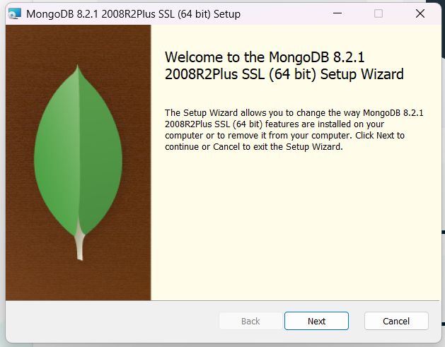

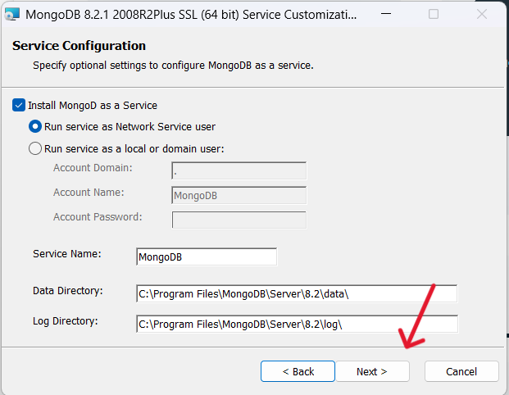
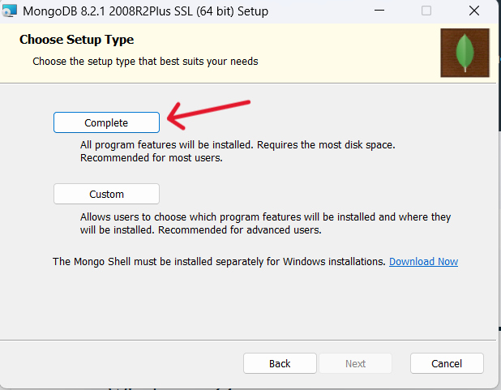

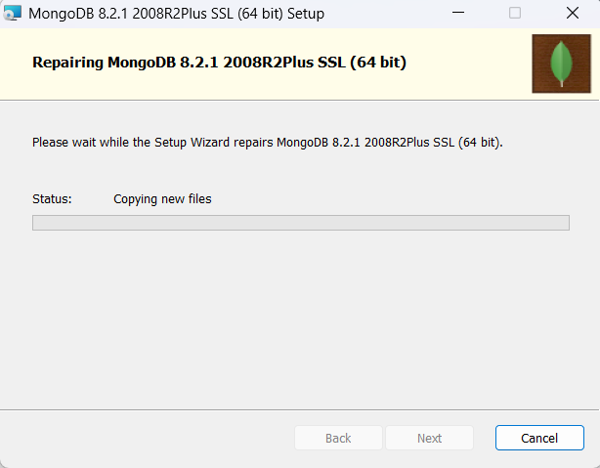
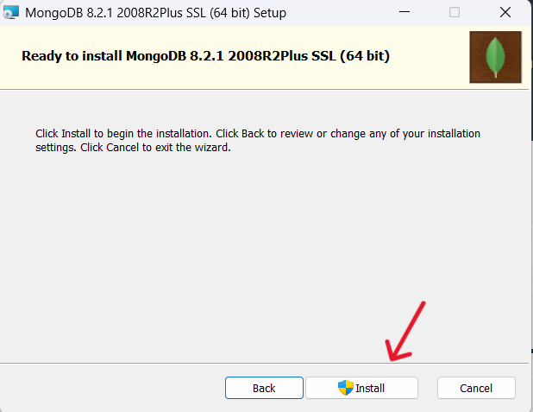
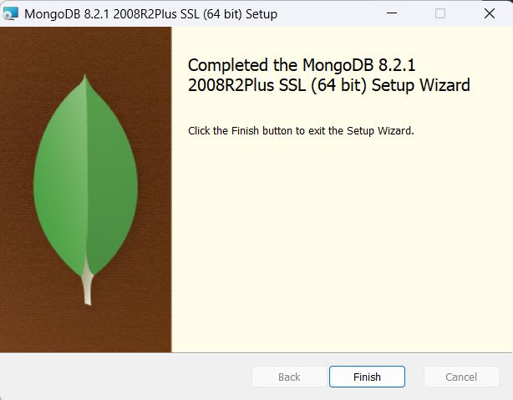

B)Write MongoDB queries to perform CRUD operations on document using insert(), find(), update(), remove()
Program:

cmd: use ravi
out: switched to db ravi

cmd: db.student.insertOne({name:"Amith",age:19,branch:"CSE"})
out: {
acknowledged: true,
insertedId: ObjectId('68e8d8d1d790aa18308295cd')
}

cmd: db.student.find({name:"srinu"})
out: {
_id: ObjectId('68e899f74675904b6bb1f33e'),
name: 'srinu',
age: 25,
branch: 'CSE'
}
cmd: db.student.updateOne({ name: "srinu" }, { $set: { age: 21 } });
out: {
acknowledged: true,
insertedId: null,
matchedCount: 1,
modifiedCount: 1,
upsertedCount: 0
}

cmd: db.student.deleteOne({name:"srinu"})
out: {
acknowledged: true,
deletedCount: 1
}

Exercise-15. MongoDB – Databases, Collections and Records

A)Write MongoDB queries to Create and drop databases and collections.
Program:
cmd: use srkr
Output: switched to db srkr

cmd: db
Output: srkr

cmd: db.dropDatabase()
Output: { ok: 1, dropped: 'srkr' }

cmd: db.createCollection("branch")
Output: { ok: 1 }

cmd: show collections
Output: branch

cmd: db.branch.insertOne({name:"CSE"})
Output: {
acknowledged: true,
insertedId: ObjectId('68e8dd7d970696cc2c198aeb')
}

cmd: db.branch.drop()
Output: true

B)Write MongoDB queries to work with records using find(), limit(), sort(), createIndex(), aggregate().
Program:

////Creating DataBase
cmd: use collegeDB
out: switched to db collegeDB

cmd: db.students.insertMany([
{ _id: 1, name: "Alice", age: 22, dept: "CSE", marks: 85 },
{ _id: 2, name: "Bob", age: 21, dept: "ECE", marks: 75 },
{ _id: 3, name: "Charlie", age: 23, dept: "CSE", marks: 90 },
{ _id: 4, name: "David", age: 20, dept: "MECH", marks: 70 },
{ _id: 5, name: "Eve", age: 22, dept: "ECE", marks: 88 }
])
out: {
acknowledged: true,
insertedIds: {
'0': 1,
'1': 2,
'2': 3,
'3': 4,
'4': 5
}
}

////Find()
cmd: db.students.find()
out: [
{ _id: 1, name: "Alice", age: 22, dept: "CSE", marks: 85 },
{ _id: 2, name: "Bob", age: 21, dept: "ECE", marks: 75 },
{ _id: 3, name: "Charlie", age: 23, dept: "CSE", marks: 90 },
{ _id: 4, name: "David", age: 20, dept: "MECH", marks: 70 },
{ _id: 5, name: "Eve", age: 22, dept: "ECE", marks: 88 }
]

cmd: db.students.find({ dept: "CSE" })
out: [
{ _id: 1, name: "Alice", age: 22, dept: "CSE", marks: 85 },
{ _id: 3, name: "Charlie", age: 23, dept: "CSE", marks: 90 }
]

////Limit()
cmd: db.students.find().limit(3)
out: [
{ _id: 1, name: "Alice", age: 22, dept: "CSE", marks: 85 },
{ _id: 2, name: "Bob", age: 21, dept: "ECE", marks: 75 },
{ _id: 3, name: "Charlie", age: 23, dept: "CSE", marks: 90 }
]

////sort()
cmd: db.students.find().sort({ marks: 1 }) /Ascending
out: [
{ _id: 4, name: "David", age: 20, dept: "MECH", marks: 70 },
{ _id: 2, name: "Bob", age: 21, dept: "ECE", marks: 75 },
{ _id: 1, name: "Alice", age: 22, dept: "CSE", marks: 85 },
{ _id: 5, name: "Eve", age: 22, dept: "ECE", marks: 88 },
{ _id: 3, name: "Charlie", age: 23, dept: "CSE", marks: 90 }
]

cmd: db.students.find().sort({ marks: -1 }) /Decending
out: [
{ _id: 3, name: "Charlie", age: 23, dept: "CSE", marks: 90 },
{ _id: 5, name: "Eve", age: 22, dept: "ECE", marks: 88 },
{ _id: 1, name: "Alice", age: 22, dept: "CSE", marks: 85 },
{ _id: 2, name: "Bob", age: 21, dept: "ECE", marks: 75 },
{ _id: 4, name: "David", age: 20, dept: "MECH", marks: 70 }
]

////createIndex()
cmd: db.students.createIndex({ dept: 1 })
out: dept_1

////aggregate()
cmd: db.students.aggregate([
{ $group: { _id: "$dept", avgMarks: { $avg: "$marks" } } }
])
out: [
{ _id: "MECH", avgMarks: 70 },
{ _id: "CSE", avgMarks: 87.5 },
{ _id: "ECE", avgMarks: 81.5 }
]

Exercise-16. Augmented Programs

A)Design a to-do list application using NodeJS and ExpressJS.
Program:

App.js
const express = require('express');
const bodyParser = require('body-parser');
const app = express();
const PORT = 3000;
app.use(bodyParser.urlencoded({ extended: true }));
app.use(express.static('public'));
app.set('view engine', 'ejs');
let tasks = [];
app.get('/', (req, res) => {
res.render('index', { tasks });
});
app.post('/add', (req, res) => {
const task = req.body.task;
if (task) tasks.push(task);
res.redirect('/');
});
app.post('/delete', (req, res) => {
const index = parseInt(req.body.index);
if (!isNaN(index)) tasks.splice(index, 1);
res.redirect('/');
});
app.listen(PORT, () => {
console.log(`To-Do app running at http://localhost:${PORT}`);
});

Index.ejs
<!DOCTYPE html>
<html>
<head>
<title>To-Do List</title>
<link rel="stylesheet" href="/style.css">
</head>
<body>
<div class="container">
<h1>My To-Do List</h1>
<form action="/add" method="POST">
<input type="text" name="task" placeholder="Add a new task" required />
<button type="submit">Add</button>
</form>
<ul>
<% tasks.forEach((task, index)=> { %>
<li>
<%= task %>
<form action="/delete" method="POST" style="display:inline;">
<input type="hidden" name="index" value="<%= index %>" />
<button type="submit">Delete</button>
</form>
</li>
<% }) %>
</ul>
</div>
</body>
</html>

Output:
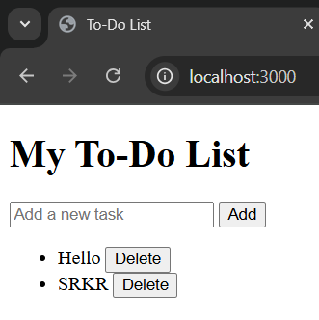

B)Design a Quiz app using ReactJS.
Program:

App.js
import React, { useState } from "react";
import "./App.css"; // Import the CSS file

const quizData = [
{
question: "Which language is used for styling web pages?",
options: ["HTML", "JQuery", "CSS", "XML"],
answer: "CSS",
},
{
question: "Which is not a JavaScript Framework?",
options: ["Python Script", "JQuery", "Django", "NodeJS"],
answer: "Django",
},
{
question: "Which is used to connect to a Database?",
options: ["PHP", "HTML", "JS", "All"],
answer: "PHP",
},
{
question: "ReactJS is developed by?",
options: ["Google", "Microsoft", "Facebook", "Twitter"],
answer: "Facebook",
},
];

export default function App() {
const [current, setCurrent] = useState(0);
const [score, setScore] = useState(0);
const [selected, setSelected] = useState("");
const [showScore, setShowScore] = useState(false);

const handleOptionClick = (option) => setSelected(option);

const handleNext = () => {
if (!selected) {
alert("Please select an answer!");
return;
}

if (selected === quizData[current].answer) {
setScore(score + 1);
}

setSelected("");

if (current + 1 < quizData.length) {
setCurrent(current + 1);
} else {
setShowScore(true);
}
};

const restartQuiz = () => {
setCurrent(0);
setScore(0);
setSelected("");
setShowScore(false);
};

return (
<div className="quiz-body">
<div className="quiz-container">
<h1 className="quiz-title">React Quiz App</h1>

{showScore ? (
<>
<div className="score-section">
🎯 Your Score: {score} / {quizData.length}
</div>
<button className="restart-btn" onClick={restartQuiz}>
Restart Quiz
</button>
</>
) : (
<>
<div className="question">
Q{current + 1}. {quizData[current].question}
</div>

<div className="options">
{quizData[current].options.map((option) => (
<button
key={option}
onClick={() => handleOptionClick(option)}
className={`option-btn ${
selected === option ? "selected" : ""
}`}
>
{option}
</button>
))}
</div>

<button className="next-btn" onClick={handleNext}>
{current === quizData.length - 1 ? "Finish" : "Next"}
</button>
</>
)}
</div>
</div>
);
}

Index.js
import React from "react";
import ReactDOM from "react-dom/client";
import App from "./App";

ReactDOM.createRoot(document.getElementById("root")).render(<App />);

App.css
/* ====== Quiz App Styling ====== */

body, html {
margin: 0;
padding: 0;
font-family: "Poppins", sans-serif;
background: linear-gradient(135deg, #667eea, #764ba2);
height: 100vh;
}

/* Center the quiz card */
.quiz-body {
display: flex;
justify-content: center;
align-items: center;
height: 100%;
}

.quiz-container {
background: #fff;
width: 400px;
max-width: 90%;
border-radius: 16px;
box-shadow: 0 10px 25px rgba(0, 0, 0, 0.2);
padding: 30px;
text-align: center;
transition: all 0.3s ease;
}

.quiz-container:hover {
transform: scale(1.02);
}

.quiz-title {
color: #4b56d2;
font-size: 26px;
font-weight: 700;
margin-bottom: 20px;
}

.question {
font-size: 18px;
margin-bottom: 20px;
color: #333;
}

.options {
display: flex;
flex-direction: column;
gap: 10px;
}

.option-btn {
border: 2px solid #ddd;
padding: 10px 15px;
border-radius: 10px;
background-color: #f8f8f8;
cursor: pointer;
font-size: 16px;
transition: all 0.25s ease;
}

.option-btn:hover {
background-color: #eaeaff;
border-color: #4b56d2;
}

.option-btn.selected {
background-color: #4b56d2;
color: #fff;
border-color: #4b56d2;
}

.next-btn {
margin-top: 20px;
background-color: #4b56d2;
color: #fff;
border: none;
padding: 10px 25px;
border-radius: 8px;
font-size: 16px;
cursor: pointer;
transition: 0.3s;
}

.next-btn:hover {
background-color: #3a45b0;
}

.score-section {
font-size: 20px;
font-weight: 600;
color: #222;
margin-bottom: 20px;
}

.restart-btn {
background-color: #4b56d2;
color: #fff;
border: none;
padding: 10px 25px;
border-radius: 8px;
cursor: pointer;
transition: 0.3s;
}

.restart-btn:hover {
background-color: #3a45b0;
}
Output:

